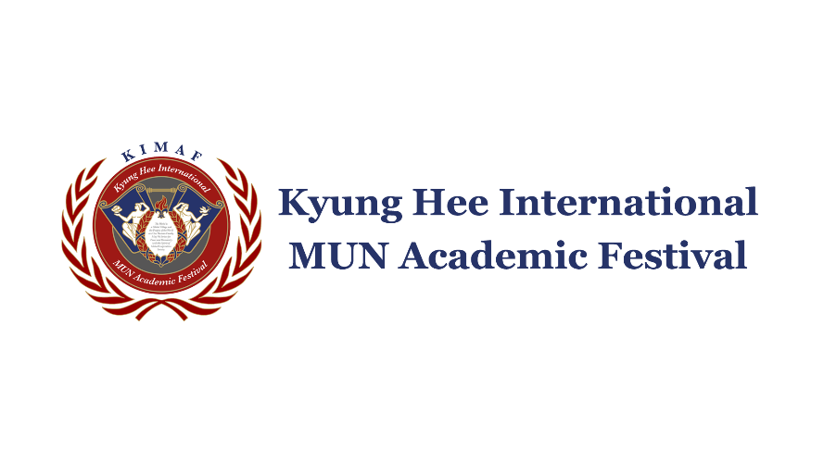

KIMAF 2022: Peace Building and Sustainable Prosperity
Application Form

- Personal Information (인적사항) (Up to THREE people for team entry)
[Team member #1] – Team Representative
Korean Name/English Name  (국문성명/영문성명)  *영문이름은 여권 영문명 |  | Photo
Date of Birth (yyyy/mm/dd)
(생년월일)
Department/Major/Grade
(단과대/전공/학년)
Phone Number (휴대폰 번호)
Emergency Contact (비상 연락처)
Email Address (이메일 주소)
Address & Zip code (자택 주소 및 우편번호) *Please write in Korean

[Team member #2]
Korean Name/English Name  (국문성명/영문성명)  *영문이름은 여권 영문명 |  | Photo
Date of Birth (yyyy/mm/dd)
(생년월일)
Department/Major/Grade
(단과대/전공/학년)
Phone Number (휴대폰 번호)
Emergency Contact (비상 연락처)
Email Address (이메일 주소)
Address & Zip code (자택 주소 및 우편번호) *Please write in Korean

[Team member #3]
Korean Name/English Name  (국문성명/영문성명)  *영문이름은 여권 영문명 |  | Photo
Date of Birth (yyyy/mm/dd)
(생년월일)
Department/Major/Grade
(단과대/전공/학년)
Phone Number (휴대폰 번호)
Emergency Contact (비상 연락처)
Email Address (이메일 주소)
Address & Zip code (자택 주소 및 우편번호) *Please write in Korean

2. Applying Information (지원 정보)
Applying Section (출품 분야)  * Up to THREE people can collaborate to submit a team entry in MULTIMEDIA Field *  * Choosing between Card News / UCC / Poster is MANDATORY * | Multimedia field  Section: Card News ( ) / UCC ( ) / Poster ( )

- Account Information (계좌 정보) (The purpose is to provide scholarships for winners, so please provide accurate information in KOREAN) * Please provide the following information in the name of ‘TEAM REPRESENTATIVE’. *
Name of Bank (은행명)
Account Number (계좌번호)
Name of Depositor (예금주)
Name of Depositor (입금자명)

4. Agreement on Collecting and Using Personal Information (개인정보 수집 및 활용 동의서)
Kyung Hee College of International Studies collects and uses personal information regarding KIMAF 2022: Peace Building and Sustainable Prosperity participation as follows and handles necessary matters to ensure that personal information is safely managed in accordance with relevant laws and regulations.

1. Consent to the collection and use of personal informations
- Use of collected information: KIMAF 2022: Peace Building and Sustainable Prosperity.
- Personal information items to be collected: Name (Korean, English), date of birth, phone number, email, address, student information, account information.
- Period of retention and use of personal information: Subject to the period prescribed by the relevant statutes.
- Disadvantages of non-consenting: You may agree or disagree with the use of personal information. The personal information collected is a minimum required item for the participation in KIMAF 2022: Peace Building and Sustainable Prosperity.
- If you disagree, you cannot participate in KIMAF 2022: Peace Building and Sustainable Prosperity.

Team member #1 _ Write your name here (인/Signature)
Team member #2 _ Write your name here (인/Signature)
Team member #3 _ Write your name here (인/Signature)

- The undersigned hereby transfer any and all rights in and to the entry including without limitation all copyrights to KICMUN Secretariat.

- All submitted entries shall not be returned regardless of whether they are winning entries or not, and may be used for public interest such as publication, exhibition, education, public relations, etc. In such cases, this includes writing and using them as a secondary work other than simply using them as it is.

- Participants have the right to refuse the above content, but if they refuse to consent, they may be excluded from the evaluation process.

Write TEAM REPRESENTATIVE’s name here (인/Signature)
5. Copyright Agreement (저작권 이용 허락 동의서)

- I have recognized that if the submitted entry does not meet the minimum standards of the evaluation regulations (e.g., an insincere work, a plagiarized work), the certificate and souvenirs cannot be provided and the refund of the participation fee is not possible.

- I have recognized that the submitted entry should be my own work that has never been submitted before. If it is found to be imitated / plagiarized / done by another party, the entry itself will fail to be evaluated. When the entry falls under such cases above, the award
qualification will be revoked whatsoever even if it ended up being selected as a winning entry.

- I have recognized that there shall be no problem with the copyright of the submitted entry, that the award of the submitted entry will be revoked in the case of infringement of the copyright due to plagiarism, reproduction, etc. even after the evaluation process. Participants shall bear full responsibility in the event of a dispute.

- I have recognized that if the submitted entry differs from previously submitted application form (e.g., change of entry field), the entry may be excluded from the evaluation process.

Write TEAM REPRESENTATIVE’s name here (인/Signature)
6. Waiver Form (서약서)

- Once the application form has been submitted, changing the ENTRY SECTION (Card News / UCC / Poster) afterward is prohibited for any reasons / circumstances.

- Application Form File Format (MUST BE IN KOREAN): ‘카드뉴스/UCC/포스터 중 택1 _ 팀 대표자 대학명 및 성명 _ 휴대전화 뒷번호 4자리’
-> The form MUST be finally submitted to https://forms.gle/F1XekbeFHJtkYSR2A

- For submitting a final entry, HOWEVER, it MUST be submitted via kicmun@naver.com

- Please thoroughly check GUIDEBOOK which includes detailed instructions and guidelines participants should follow when submitting a final entry (* Guidebook can be found on the KICMUN Secretariat website https://www.kicmun.org/)

Confirmed( )
7. Things to Note (지원서 제출 전 참가자 필독사항)

